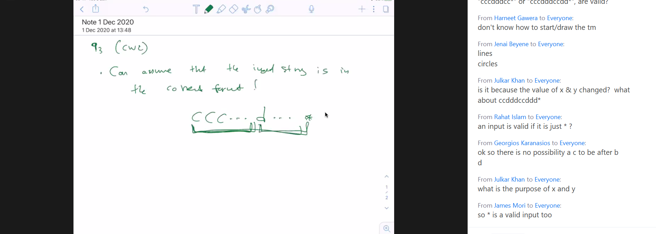

CNN notes

For image recognition, MLP neural networks will often flatten each image and ‘dump’ to a neuron. This can cause loss of information. Therefore CNNs use a ‘onvolution’ where a Kernel ( a matrix which acts like a filter) used of a specific size and scans over each pixel of the input image. It then does a dot product with the corresponding pixels. The kernel continuously updates as it scans across the entire image. You can also indicate a stride and padding value to improve information gathered about each feature in an image.